SEEKING PARTICIPANTS
FOR BREAST CANCER STUDY

Are you an African American female who has been diagnosed with breast cancer?

Would you be interested in participating to discuss your experience with being diagnosed with breast cancer?

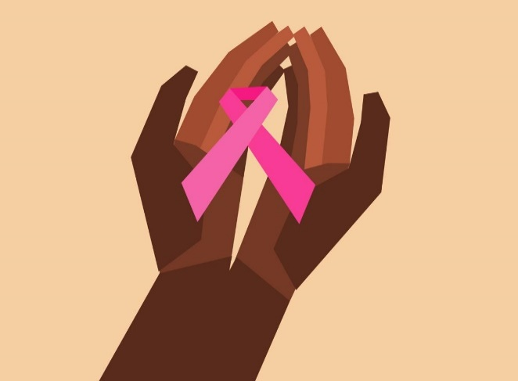

WHAT? This interview study explores your views in what it is like for you to live with and/or survive breast cancer. We intend to improve healthcare delivery on this topic. This study has been approved San Diego State University Institutional Review Board. Your participation is voluntary and confidential.
WHO? African American women who have some experience with breast cancer diagnosis. We are interested in hearing from you if you are female and age 18 and over and have been diagnosed with breast cancer.

WHERE? Southern and Northern California

WHEN? Arranged

For participating in a brief survey and an in-depth interview that takes about 40 – 60 minutes, you will receive a $20 digital gift card from Amazon.

If you would like to find out more about the study, and see if you qualify, please contact me by replying directly to me. I will provide more details and ask you to answer some questions about your experience. Thank you for your consideration!

Angelica Addison, MA, and current Masters of Social Work student at San Diego State

aaddison@sdsu.edu

or

Frances Nedjat-Haiem, MSW, PhD, and Thesis Advisor
San Diego State University, School of Social Work 619-594-6860 fnedjathaiem@sdsu.edu

